CaRe

Vision Document

Version 1.0

Revision History

| **Date** | **Version** | **Description** | **Author** |
| --- | --- | --- | --- |
| 31/10/2023 | 1.0 | Initial version | Triệu Nhật Minh |
|  |  |  |  |
|  |  |  |  |
|  |  |  |  |

Table of Contents

1. Introduction 4

2. Positioning 4

2.1 Problem Statement 4

2.2 Product Position Statement 4

3. Stakeholder and User Descriptions 4

3.1 Stakeholder Summary 4

3.2 User Summary 5

3.3 User Environment 5

3.4 Summary of Key Stakeholder or User Needs 5

3.5 Alternatives and Competition 6

4. Product Overview 6

4.1 Product Perspective 6

4.2 Assumptions and Dependencies 7

5. Product Features 7

6. Non-Functional Requirements 9

Vision (Small Project)

# Introduction

The introduction of the Vision document provides an overview of the entire document. It includes the purpose and references of this Vision document.

# Positioning

## Problem Statement

| **The problem of** | Reading reviews about that shop to decide whether people should go to that shop and booking tables in advance to avoid running out of tables. |
| --- | --- |
| **affects** | A rating and review app for cafés and customers. Customers can evaluate coffee, service, ambiance, and price. Cafés can get feedback and improve their business. |
| **the impact of which is** | Customers avoid time-consuming to the coffee shops that have the worst services quality. High-quality coffee shops can emerge and increase their income. |
| **a successful solution would be** | Provide not only customers but also shops with an effective way to order and manage bookings without intermediate steps. In addition, it will help shops joining in this project increase profit through an increase in the number of customers and a decrease in the number of used tables. |

## Product Position Statement

| **For** | coffeeholics, teenagers and the youth who in the age 15 - 30 |
| --- | --- |
| **Who** | enjoy going to café shop for hanging out with friends, check-in or using workspace to study/work. |
| **The CaRe** | is a website |
| **That** | provide the full information of that café shop including description, address, menu, etc., or can be known as review and help users to book, preserve tables. |
| **Unlike** | Facebook, Google map or reviews from bloggers. |
| **Our product** | focuses only on cafés and provides more detailed and relevant information for users. CaRe also benefits café owners with a platform in which they can upload information about their cafés and interact with customers’ reviews. |

# Stakeholder and User Descriptions

## Stakeholder Summary

| Name | Description | Responsibilities |
| --- | --- | --- |
| Developers | Members of group 06 | - Rewrite the project deliverables to ensure they can be finished on time and easily maintained afterwards.  - Track the project milestones and report any issues or delays. |
| Assigned teaching assistant | Teacher Ngo Ngoc Dang Khoa  *Teacher Truong Phuoc Loc* | - Give comments, advices and directions to the development team  - Evaluate the development team's performance |

## User Summary

| **Name** | **Description** | **Responsibilities** | **Stakeholder** |
| --- | --- | --- | --- |
| End-Users (Customers) | People access website to read reviews and book tables. | Report bug of website (related to booking, adding comments, …)  Use website’s features.  Report any shops that have poor service qualities to administrator. | Self-represented |
| End-Users (Shops) | People access website to manage facilities and increase their revenue by uploading their menu and services. | Upload images to website.  Manage customers’ booking:  + View the list of bookings and their status.  + Update the status of a booking.  + Report false comments about orders. | Self-represented |
| Administrator | Administrator is a person who can ban any users violating community standards. | The only one and also the most important role of administrator is to verify reports from any end-users including customers and shops to give an appropriate ban for end-users violating community standards. | Self-represented |

## User Environment

To perform a full order process, it requires **at least** 2 people: customer and staff. The time of booking’s approved or denied is based on that shop, but the shop should answer immediately if user book in opening time, and the time to answer the booking is one day if they book at other time. If the booking is approved, customers should not be late more than 30 minutes. Their booking will be cancelled when they are late more than 30 minutes.

In theory, this project can run normally on any devices which have browsers and can access to the Internet. Nonetheless, it is really important to note that there are numerous devices and browsers so it really hard to control the efficiency of this project. However, in the further future, all members will concentrate on this project with high determination and hard work to ensure that it will be compatible with as many environments as possible. In addition, instead of browsers, applications in all platforms will be release soon.

## Summary of Key Stakeholder or User Needs

| **Need** | **Priority** | **Concerns** | **Current Solution** | **Proposed Solutions** | |
| --- | --- | --- | --- | --- | --- |
| Choose suitable table | High | other’s bookings, number of tables | Disable the type of table that ran out at that time. | | Implement the optimal algorithm to maximize the number of customers with at least tables at any time. |
| Find nearby coffee shops | High | Data for finding places | Find all the shops that have the same district as the user. | | Use API from Google Map, Apple Map to show the direction to nearby shops with the real time location of users. |
| Statistics of shops | Low | Summary data in week, month, year | Update average income, the number of bookings, … every week, month, and year. | | Apply artificial intelligence to gain insight into collected data and use machine learning to rate and show the optimal way to increase profit of these shops |

## Alternatives and Competition

| Criteria | Facebook | Google Maps | Bloggers’ reviews | CaRe |
| --- | --- | --- | --- | --- |
| User account | ✓ | ✓ | X | ✓ |
| Order tracking | X | X | X | ✓ |
| Report orders | X | X | X | ✓ |
| Review with images and comments | ✓ | ✓ | ✓ | ✓ |
| Shops suggestion | X | X | ✓ | ✓ |
| Report shop | X | X | X | ✓ |
| Delete poor service shops | X | X | X | ✓ |
| Privacy | X | X | X | ✓ |

# Product Overview

## Product Perspective

* The following diagram summarizes the interaction between systems of 3 main roles of the user. They will list features of each role defining in the website.

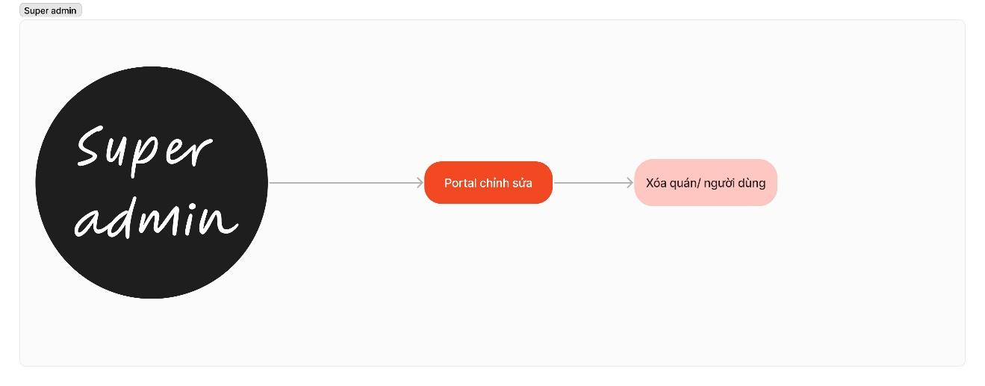

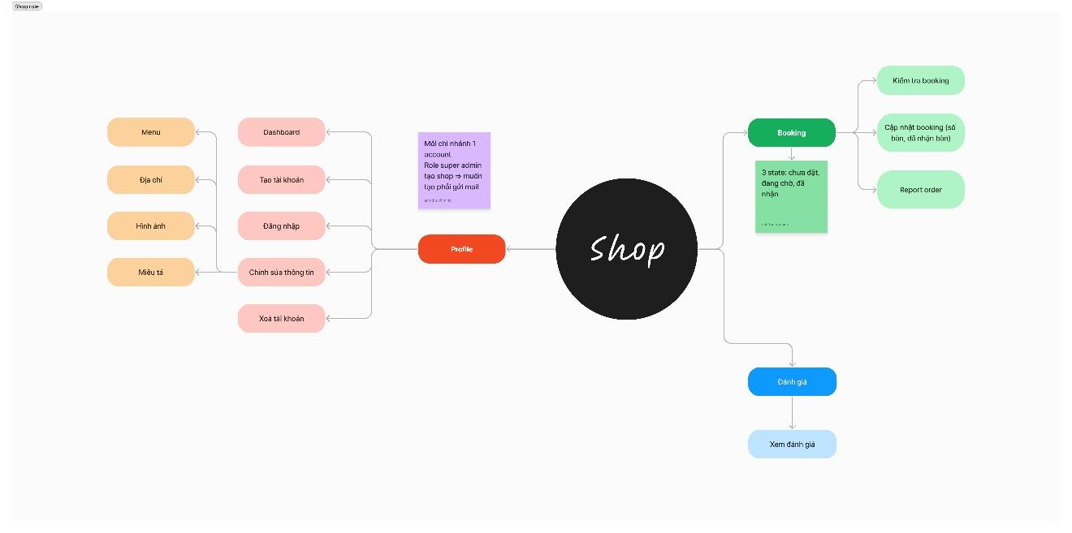

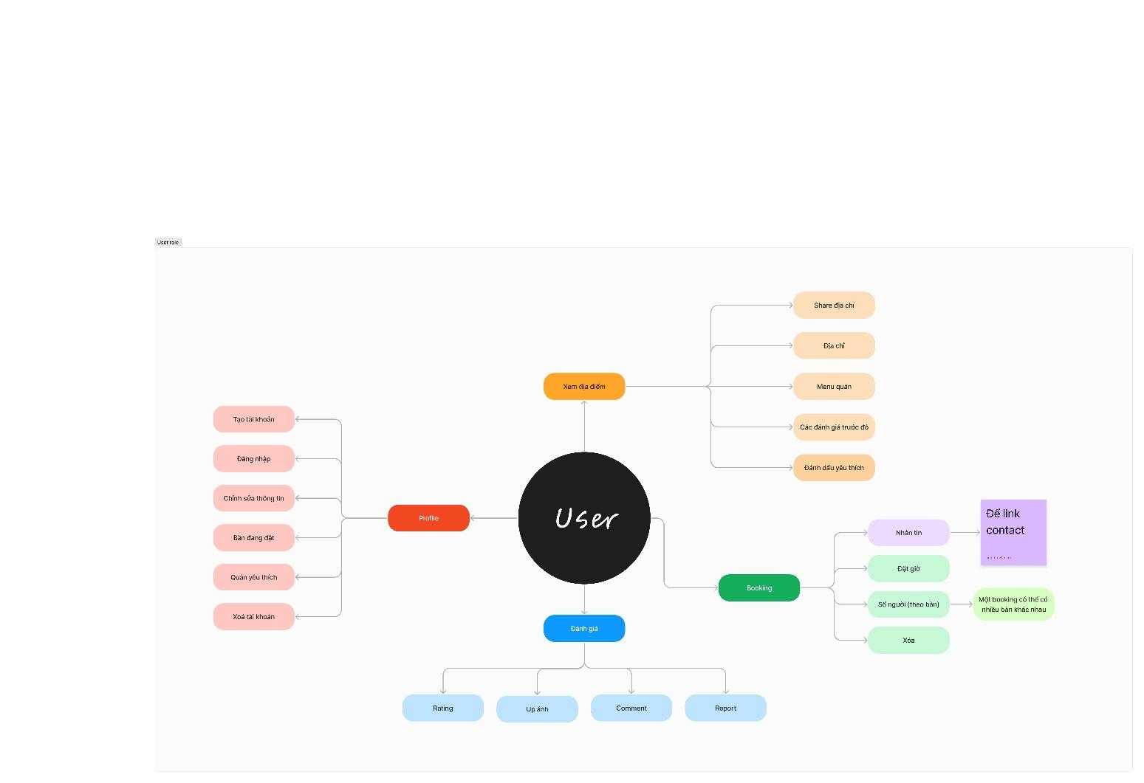

## Assumptions and Dependencies

* DDOS: the system of websites will be overloaded in a period of time due to the size of the attacks, and real users can not access to do anything in this time. This will create terrible services for both customers and shops. Hence, it requires some effective ways to deal with this problem, such as Cloudflare…
* Fake orders: There will be a huge amount of orders to shops that are out of service, but there are no customers to come.
* False information: fraud customers by incorrect information such as: price, quality of service, …

# Product Features

| No | Feature | Description | Priority |
| --- | --- | --- | --- |
| 1 | [User + Shop] Sign up | Users and shops are able to create new accounts in the system, choose roles. New accounts must provide basic information to authenticate and authorize such as email, password, phone, address, etc. | High |
| 2 | [User + Shop] Log in | Users and shops must be able to log in to their accounts with registered email and password. | High |
| 3 | [User + Shop] Log out | Users and shops can be log out from their accounts. | High |
| 4 | [User] Edit general information | Users can edit their general information and change password. | High |
| 5 | [User] Search coffee shop | Users can search by keywords, filters, or location. See distance, hours, and contact for each cafe. | High |
| 6 | [User] Filter coffee shop | User chooses the specific tags, location and the web will render the coffee shop list matched all requirements. | Low |
| 7 | [User] View coffee shop’s information | Allow users to view all the information of chosen coffee shop including the general info: description, open-time, phone, average price, etc. as well as images about shop environment and menu. | High |
| 8 | [User] Home page list suggest coffee shop | Homepage will show the list of nearby coffee shops, top high-rating shops. | Low |
| 9 | [User] Add comment and rating | Users are able to add comments and give rating points to coffee shops they visited or booked and order. | High |
| 10 | [User] Change password | Allow users to edit general information (excluding email) and allow them to change passwords. | High |
| 11 | [User] Delete account | Users can delete accounts themselves if they no longer need the website. | High |
| 12 | [User] Report shop | Users can report the shops with low quality services. | Low |
| 13 | [Shop] Edit shop information | Beside general information, shops must be allowed to edit, update or delete their images, description. Moreover, if they close their shops permanently or for some reason, they don’t use the website anymore, the website must allow them to delete their account. | High |
| 14 | [Shop] View list reviews | Shops can view the list of reviews their customers give them. | Medium |
| 15 | [User] Booking | Allow users to reserve a variety of tables at specific times. | High |
| 16 | [Shop] Manage booking | Allow coffee owners to view a list of booking, accept or reject the reservation. | High |
| 17 | [Shop] Dashboard | Visualize the number of booking, reviewing (monthly, weekly, etc.), and average rating. | Low |
| 18 | [User] Favorite shops | List of shops that the user has liked. | Low |
| 19 | [User] Shop recommendations | Suggest user the coffee shops that in top rated, based on their location or their favorite list. | Low |
| 20 | Administrator portal | The website must give the private page for the administrator to manage all the accounts, allow them to access the database through UI and manage all the reports. | Low |

# Non-Functional Requirements

Organizational requirements:

* Delivery requirements:
  + Completed in 3 months.
  + At least 3 features
* Implementation requirements:
  + Front-end: ReactJS
  + Back-end: ExpressJS
  + Database: MongoDB
* Standards requirements:
  + On-time delivery

Product requirements:

* Efficiency requirements:
  + Space requirements
    - Comment: up to 1000 characters
    - Image: up to 2MB per image
  + Performance requirements
    - Small time to load.
* Usability requirements:
  + Friendly interface:
    - Navigate
    - Button
    - Heading
    - Help/error messages
    - Clear description
  + Low perceived workload:
    - Clearly instruction
    - Minimal steps
* Reliability requirements:
  + Verification requirements
* Portability requirements:
  + Many devices:
    - Phone
    - Tablet
    - Laptop
  + Many browsers
    - Firefox
    - Safari
    - Chrome

External requirements:

* Interoperability requirements:
  + Encryption account’s password
* Legislative requirements:
  + Ban restricted upload content.
  + Detect disguised cafes.
* Ethical requirements:
  + Comment with no “trash” words